Final Report:

Predicting iPSC Donor Differentiation Success

Problem Statement
Cell therapy is an up-and-coming field within the pharmaceutical industry. Induced pluripotent stem cell (iPSC) based products offer huge advantages over traditional primary cell-based products because they have the potential to be much cheaper for patients. In addition, iPSCs can be edited much more efficiently and to a much greater complexity than primary cells, which enables the development of more complex and sophisticated cell therapy products than is otherwise possible.
Despite the benefits of iPSC-based cell therapy products, there are also significant challenges to developing these drugs.
- iPSC products take a long time in Research and Development since each iteration of differentiating the iPSCs to mature cell types can take months.
- When making an iPSC product, the researchers must start with hundreds of clones or donors (groups of cells that all originated from the same starting cell and are therefore genetically identical). These clones are then tested extensively to find the safest and most effective final clone to be the drug product.
- Development of iPSC-based cell therapies is extremely expensive and time-consuming.
- These limitations mean companies must limit optimization and experimentation.
These issues could be alleviated through machine learning models which use data on iPSC starting material to predict which iPSC source will have the most success during drug development. These models would save an incredible amount of time and resources to allow faster and more efficient cell therapy drug development.
This is a complex task and solving the entire problem would be beyond the scope of this Capstone project. Instead, this project demonstrates how models can be used to automate one piece of the iPSC cell therapy pipeline, stem cell donor selection.
The first step in developing an iPSC-based cell therapy drug is selecting the starting material, which is taken from healthy donors. iPSCs from different donors can vary widely in their ability to become the final cell type of interest and in their efficacy to cure the disease. Often, companies only have the resources to experimentally compare a few different donors. In this project, I developed a model that uses RNAseq data on the starting iPSCs from 92 donors and uses this data to predict how well a donor will differentiate into definitive endoderm cells.

Dataset Description
The dataset used in this project is from the publication ‘Single-cell RNA-sequencing of differentiating iPS cells reveals dynamic genetic effects on gene expression’ by Cuomo et al. (https://doi.org/10.1038/s41467-020-14457-z) and includes the scRNAseq data from 125 donors as they differentiate from iPSCs to definitive endoderm (DE). Cells are collected for sequencing on day0 (iPSCs), day1, day2 and day3 (DEs). The datasets are publicly available at https://zenodo.org/record/3625024#.Xil-0y2cZ0s and the code from the original publication can be found at https://github.com/single-cell- genetics/singlecell_endodiff_paper/tree/main. The dataset is available as both raw and log-normalized counts. In this project I used raw_counts.csv.

Data Wrangling
The raw counts dataset had already undergone extensive data wrangling prior to publication as is typical for RNAseq datasets, so there was no need to remove dying cells or other measures of data quality. Similarly, there were no missing values or suspicious data points. The only data wrangling necessary was to put the dataset in an optimal format for this project, which included transforming the csv file into a ScanPy object called `adata`. This puts the RNA counts data in an expression matrix called X (cells as rows, genes as columns) and the metadata in a matrix called obs. From that point, we are ready to begin EDA using ScanPy.

Exploratory Data Analysis

PCA and Pseudotime
The first step of EDA when working with published bioinformatics datasets is to recreate a figure from the original publication that is crucial to the new analysis. In the adata dataset, we recreated the PCA from Figure 1c of the original publication. To do this, we created a new dataset with only the top 500 most variable genes (HVGs) called adata_hvgs and ran a standard PCA within ScanPy (Figure 1, top left). This PCA shows a similar pattern of grouping the cells by day as well as similar percentages of variance explained by PC1 and PC2 as the original PCA plot from Cuomo et al. This confirms that we have interpreted and prepared the dataset correctly and can now move forward with our analysis.
The goal of this project is to build a model to predict differentiation success. However, defining differentiation success is not necessarily straightforward. Ideally, we would have a functional readout of the cells that can help us classify donors as failed or successful. As this is unavailable for this dataset, we will use gene expression patterns in the day3 cells from each donor to make a score that the model can predict. We will do this in two ways and compare the predictions of each. These two methods are:
- Pseudotime: A score based on how differentiated a cell is relative to a starting point (random day0 cell) generated using the ScanPy function dpt.
- DE Score: A score based on high expression of typical DE cells and low expression of typical iPSC cells, generated using the ScanPy function score_genes.
At this point in the analysis we don’t have the DE score yet, but we can calculate pseudotime for each cells and use it to color the PCA (Figure 1, bottom left).

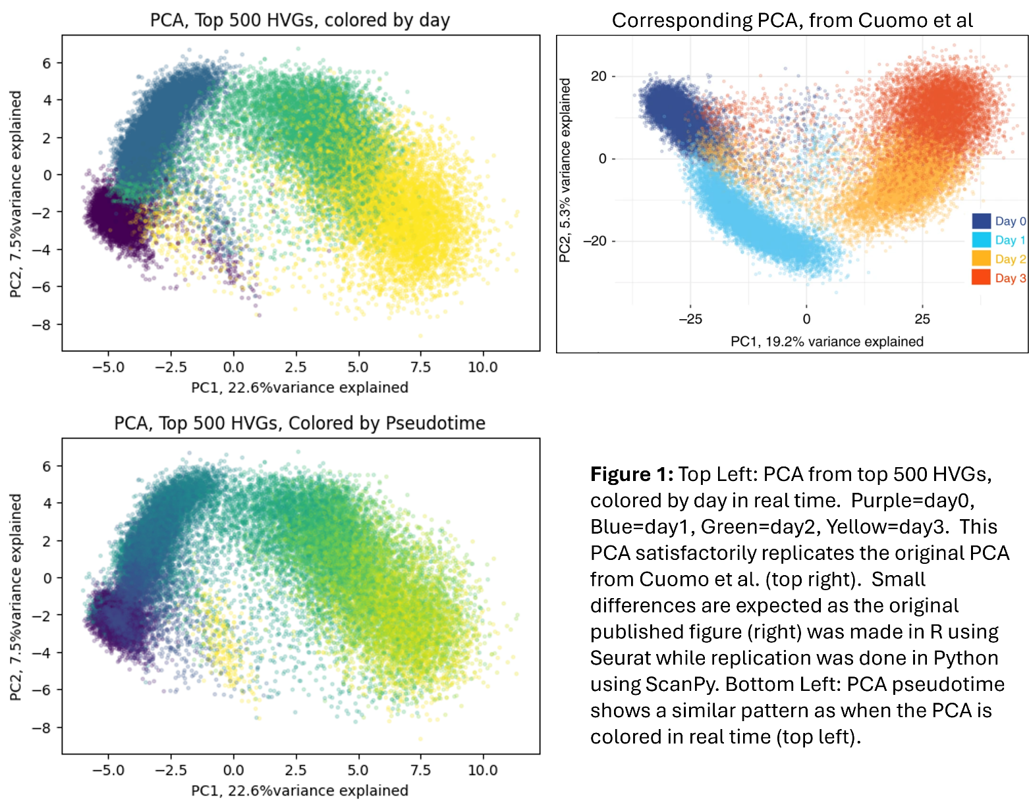
The similarity in the coloring pattern of the PCA colored by real time (Figure 1, top left) and the coloring pattern of the PCA colored by pseudotime (Figure 1, bottom left) shows us that pseudotime largely overlaps with real time and supports its use as a metric of differentiation success.

Variable Gene Expression
When evaluating a dataset describing iPSC differentiation, a crucial step is to determine that the differentiation was successful and the final cells resemble their endogenous cell type. To do this, we looked at expression patterns of known markers. First we replicated Figure 1d of the original publication (not shown), showing expression of markers NANOG, T, EOMES, GATA6, which should each be highest in doy0, day1, day2 and day3 cells, respectively (Figure 2).
Figure 3 gives us some confidence that the differentiation to endoderm was successful. To better assess whether these day3 cells resemble endogenous DE cells, we can look at a panel of iPSC markers and DE markers using a dot plot (Figure 3).

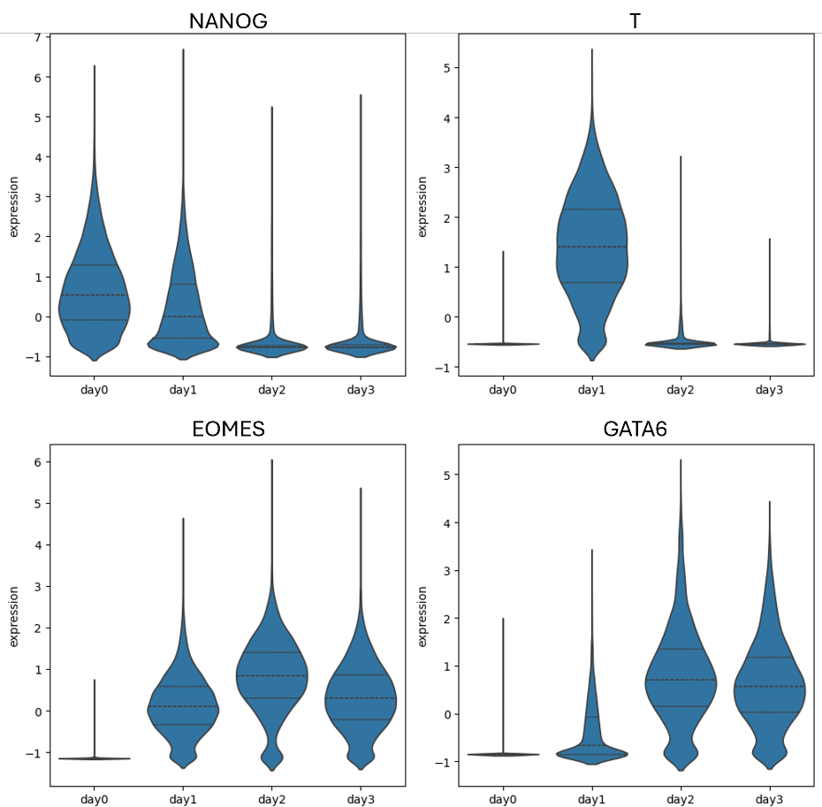
Figure 2: Expression of the four known markers NANOG, T, EOMES and GATA6 by day of differentiation.

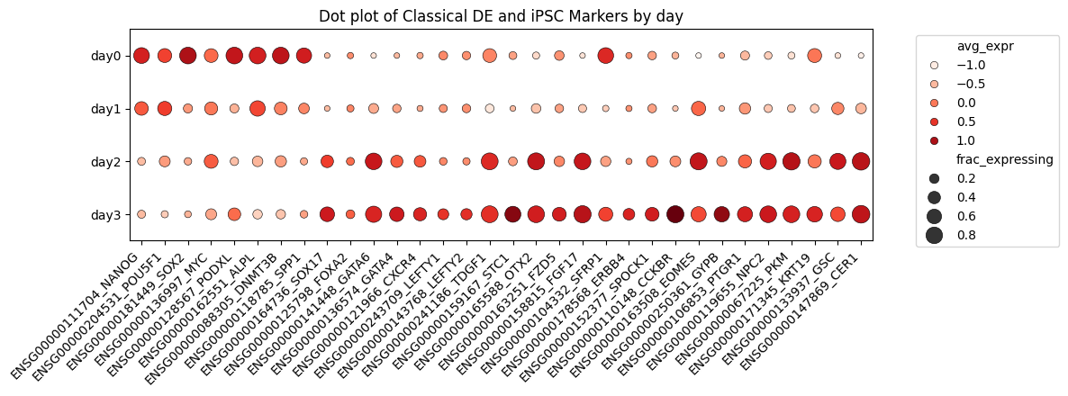
Figure 3: Expression of known iPSC markers (first 8) and DE markers by day of differentiation.
This pattern shows us that day3 cells have successfully downregulated iPSC genes and upregulated known DE genes. This gives us confidence that the differentiation to endoderm was successful overall and is a suitable dataset for modelling.
In order to build a model that can distinguish between donors, there needs to be differentiate gene expression between donors within day3 cells and within day0 cells. To assess whether there is sufficient inter-donor genetic variation, I used a function that calculates amount of variability within cells of a specfic day that can be attributed to donor differences. The resulting R2 values were sorted and plotted in Figure 4.
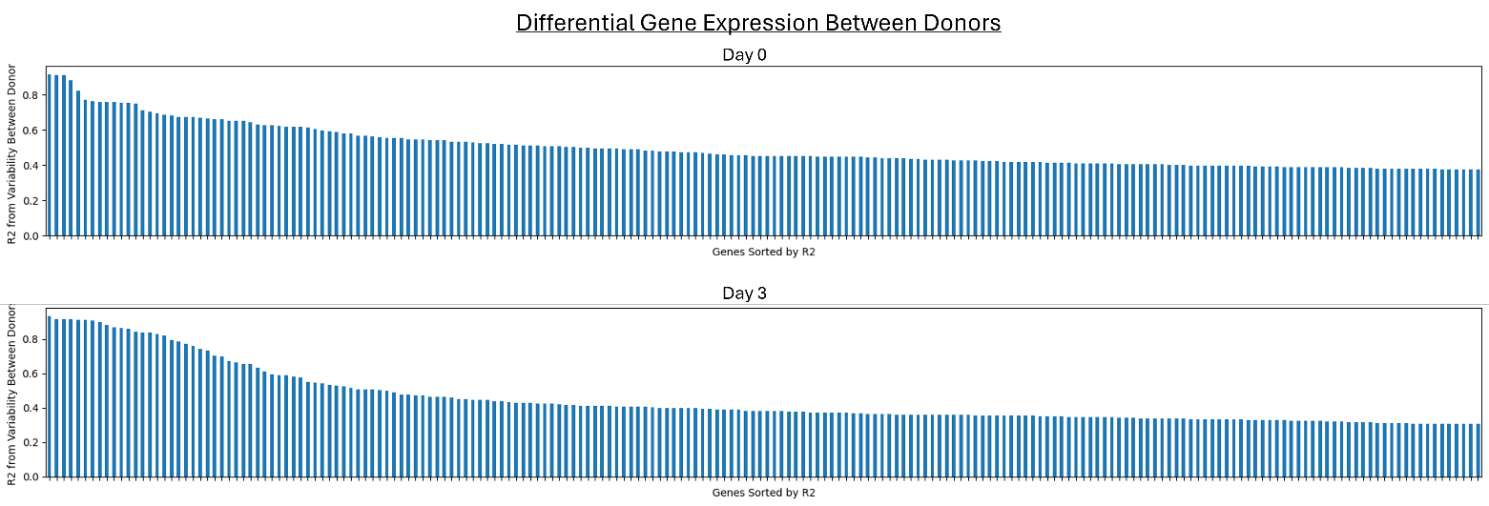
Figure 4: R2 values for correlations between donor and gene expression within Day 0 cells (top) and Day 3 cells (bottom).
Figure 4 indicates that there are sufficient numbers of genes where 50% or more of the variation in expression is due to differences between donors. These trends will form patterns that the models use to predict donor differentiation success. We will determine which specific genes are the most useful to this prediction during modelling.

Ranking Donors
The final step of our EDA is to build the metrics by which we will rank our donors. The first metric is based on pseudotime and will be called Pseudorank. Pseudorank was calculated by taking the mean pseudotime for all the day3 cells from a given donor. This value was then mapped to all cells from that donor, regardless of day. Figure 5 shows that the mean pseudotime by donor increases predictably from day0 to day3 as the experiment progresses. The day3 values represent the Pseudorank for each donor.
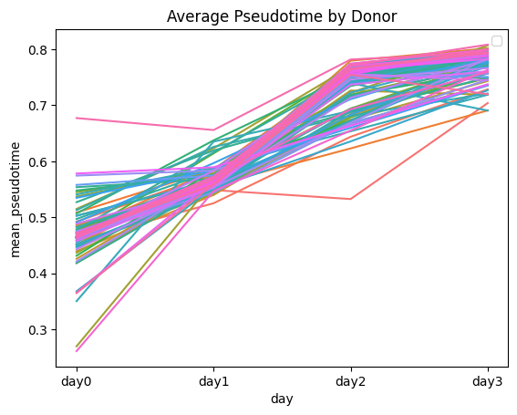
Figure 5: Mean donor pseudotime increases from day0 to day3.
The second metric by which we will rank donors is DE Score. To do this, we will use a function in ScanPy called score_genes, which take a list of genes that are expected to be high in DE cells and a list of genes that is expected to be low in DE cells and computes a numeric score for each cell in the dataset. The more challenging part of this approach is determining which genes to put in each list. In the associated notebooks, we tested this with two genes lists for DE cells. The ‘short’ list was only the well-known markers that were already used in Figure 3. This approach was found to be too simplistic and was abandoned in favor of our second, more comprehensive gene list. This ‘long’ DE marker list was generated by comparing genes high in DE cells in the current dataset with the genes high in DE cells in a similar dataset from a separate publication and research group (Chu et al). Chu did a similar differentiation from iPSC to definitive endoderm with bulk RNAseq. In short, the genes which had a mean 30-fold change in expression in the DE samples compared to the iPSC samples were collected in a list, giving us 129 DE genes and 56 iPSC genes. We did a similar analysis on our current dataset and got 187 DE genes and 127 iPSC genes. The two sets of lists were compared, and common genes were kept for the final DE gene list of 103 genes and iPSC gene list of 31 genes. Known markers were then added back in if missing and to give us final counts of 113 DE genes 37 iPSC genes. From here, we ran score_genes on the lists to create the final DE score for each cell. The donor DE scores were calculated from the mean DE Score for day3 cells for each donor. The donor DE score for day3 was mapped to all cells by donor, regardless of day, as a new column called DEscore_long.
To evaluate whether the DE score increases as expected relative to real time, we colored the PCA by DE score (Figure 6, left) and plotted the mean DE score for each donor by day. These plots indicate that the DE score increases with day as predicted and supports this method of ranking cells and donors as a measure of differentiation success.
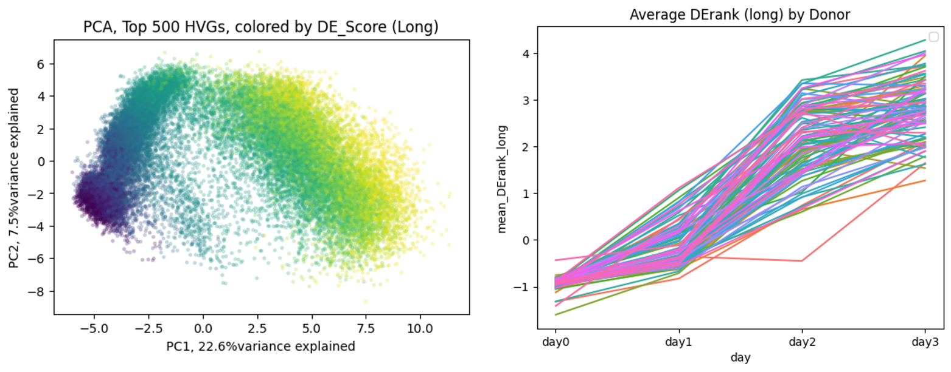
Figure 6: Left: PCA colored by DE score from the long genes list. Purple indicates the lowest score, increasing through blue, green and yellow. Right: The mean donor DE score (aka DErank) increases from day0 to day3.
Next, we compared how each of our donor ranking systems ordered the donors in our dataset using a slope chart (Figure 7). Unfortunately, this shows us that our two systems disagree over the relative positions of many of the donors, especially in the middle. As we have no functional readout to determine which ranking system is better, we will move forward with model building for both. In future work, we highly recommend increasing the scope of the next study to include a way to experimentally verify the Pseudorank and DE score readouts.

Coverting to Bulk RNAseq
The final steps of our EDA and Data Wrangling were to convert our data from single cell RNAseq to bulk RNA seq. This is standard practice for analysis done as the sample level as the variability in single cell data is often too noisy to make sample wide conclusions. Modelling was attempted from the single cell data, and the results can be found in the associated notebook called Capstone3_iPSC_Modelling_sc.
To convert our data to bulk, cells from any donor that had fewer than ten cells in both day0 and day3 were omitted. The dataset was then split by day, resulting in four datasets. Days 1 through 3 were saved and not processed further. For day0, the raw counts (saved in the ‘counts’ layer of the ScanPy object) were summed for all cells in each donor, which resulted in a new dataset called donor_adata. This dataset was then normalized and log transformed in preparation for modelling.

Model Building
Model building is shown in detail with experimentation in the accompanying notebook Capstone3_iPSC_Modelling_bulk or in a condensed form in the notebook Capstone3_iPSC_Modelling_bulk_condensed which shows the successful path to model development.
Model building proceeded through four stages:
- Dimension Reduction
- Algorithm Screening
- Optimizing Feature Selection
- Finalizing Model through Manual vs Automated Gene Selection Optimization

Dimension Reduction
The donor_adata dataset has counts for approximately 11,000 genes and 92 donors, making it a high dimensional dataset. As most of these genes will not be useful in predicting differentiation potential, three methods of dimension reduction were tested.
- Top 10 PCs from a PCA
- Molecular pathways with the greatest correlation to DE Score or Pseudorank
- Top 100 genes with the greatest correlation to DE Score or Pseudorank
The molecular pathways were taken curated gene lists published by the Broad Institute. These lists are part of the Human MSigDB Collections and are described in Liberzon et al. Gene lists of this type are used to glean information on the status and activity of the cells beyond their cellular identity. The fifty standard lists describing various normal and well characterized molecular pathways were downloaded and converted into scores for each donor using the score_genes function. We then calculated the correlation between the scores for each list and DE Score/Pseudorank. Some of the top correlations are shown in Figure 7. Notably, the pathways with high correlations made biological sense. In order to successfully differentiate into anything, iPCs must be healthy and pluripotent (Table 1). The pathways with high positive correlation with DE Score/Pseudorank include Myc or E2F targets genes, which both known to regulate gene expression in pluripotent stem cells, and G2M checkpoint and DNA repair, which would be necessary for maintaining DNA integrity during cell division. Alternatively, the pathways which negatively correlated with DE Score/Pseudorank include Apoptosis, Inflammatory or Interferon response, the P53 pathway and TNFa pathway, all of which would be upregulated in stressed, mutated or dying cells and low in healthy iPSCs.
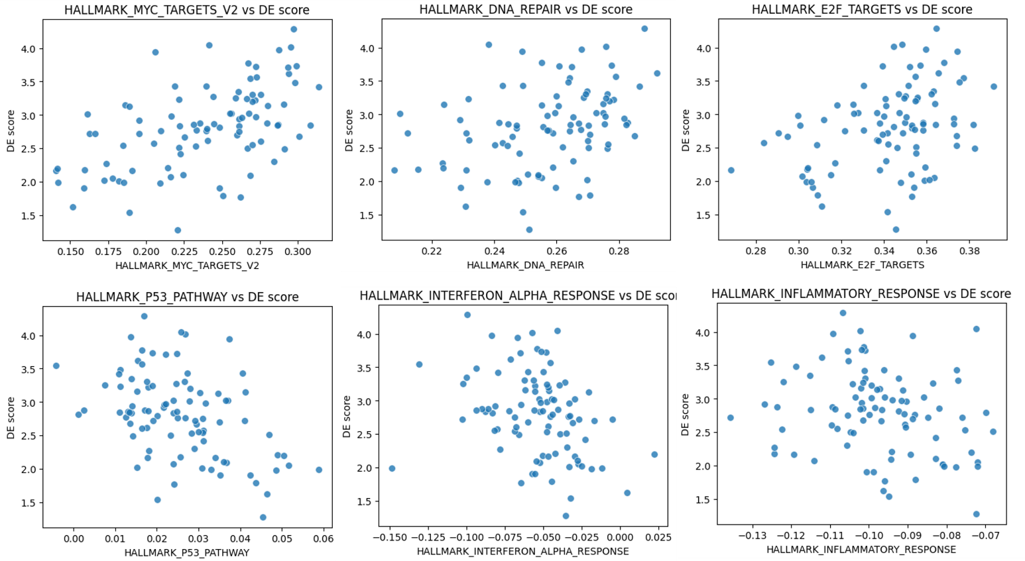
Figure 7: Myc targets, DNA repair and E2F targets are three pathways that correlated positively with DE Score (top). P53 pathway, interferon response and inflammatory response are three targets that correlated negatively with DE Score (bottom).
Pathway (Pos) | Correlation DE | Correlation PR | Pathway (Neg) | Correlation DE | Correlation PR
Myc Targets V2 | 0.539 | 0.327 | Interferon_Alpha_Response | -0.360 | -0.531
DNA Repair | 0.376 | 0.315 | Apoptosis | -0.225 | -0.511
E2F Targets | 0.353 | 0.162 | Inflammatory Response | -0.273 | -0.479
Myc Targets V1 | 0.333 | 0.167 | TNFA Signaling via NFKB | -0.430 | -0.441
G2M Checkpoint | 0.327 | 0.148 | P53 Pathway | -0.430 | -0.431
Table 1: Pathways with highest absolute correlations with DE Score or Pseudorank
The pathways with absolute correlations of 0.1 or above were combined with the top ten PCs into a new dataset called donor_pathways that was used for learner screening. As shown below, this dataset was less successful at predicting donor DE Score/Pseudorank than the dataset made of individual genes. However, the results from this pathways dataset are included in this report because the high correlations with biologically relevant pathways validates the DE Score and Pseudorank and useful metics of iPSC differentiation potential.
To efficiently find the genes with the greatest prediction ability for the purpose of learner screening, a Spearman coefficient was calculated for each gene relative to DE Score and to Pseudorank. The 100 genes with the highest absolute coefficients were collected into separate datasets called donor_score and donor_rank. Together, donor_score, donor_rank and donor_pathways were moved forward into algorithm screening.

Algorithm Screening
Five regression algorithms were tested with default settings to determine the best starting place for building a model to predict donor Pseudorank or DE Score using day0 RNA seq data. The learners were judged on their R-squared values and mean absolute error (MAE), mean absolute percent error (MAPE). The MAE and MAPE results are summarized in Table 2 and Table 3. From this summary of MAE and MAPE, we learn the following:
- MAE for PR predictions are about 20 fold lower than for DE Score predictions. This is partly due to the different scales between Pseudorank and DE Score. Normalizing the error to the target scale using MAPE results in Pseudorank predictions still have amean error rate that is 5-10 fold lower than DE Score predictions.
- Predictions based on individual genes are marginally better than predictions from full pathways.
- Best Learners: CatBoost predictions of Pseudorank are the most successful.
Learner screening was run multiple times using train/test splits with different random state seeds. Overall, the variability in MAE was greater between splits for a given learner than between learners of a given split. Random Forest and CatBoost were the top learners for most splits, but not all. To account for this variability, further model optimization will be tested over multiple splits.
Learner | genes_DE_MAE | genes_PR_MAE | pathways_DE_MAE | pathways_PR_MAE
Multiple Linear Regression | 0.73 | 0.033 | 0.63 | 0.037
Random Forest Regressor | 0.50 | 0.017 | 0.48 | 0.020
Gradient Boost Regressor | 0.54 | 0.017 | 0.47 | 0.019
XGBoost Regressor | 0.54 | 0.016 | 0.53 | 0.021
CatBoost Regressor | 0.50 | 0.015 | 0.51 | 0.019
Table 2: MAE for learners trained with donor_score (genes_DE), donor_rank (genes_PR) or donor_pathways to predict DE score (DE) or Pseudorank (PR).
Learner | genes_DE_MAPE | genes_PR_MAPE | pathways_DE_  MAPE | pathways_PR_  MAPE
Multiple Linear Regression | 0.278879 | 0.042867 | 0.302210 | 0.048444
Random Forest Regressor | 0.220917 | 0.022109 | 0.215585 | 0.026956
Gradient Boost Regressor | 0.233837 | 0.023144 | 0.216221 | 0.025477
XGBoost Regressor | 0.229096 | 0.021817 | 0.230050 | 0.028511
CatBoost Regressor | 0.217116 | 0.020755 | 0.230386 | 0.025454
Table 3: MAPE for learners trained with donor_score (genes_DE), donor_rank (genes_PR) or donor_pathways to predict DE score (DE) or Pseudorank (PR).
The most likely practical use of this type of model is to select the top few iPSC for experimental verification in the lab. It’s therefore just as important for the model to rank the donors correctly as it is to accurately predict donor score. To address this, donors were ranked according to their predicted and actual scores and the orders were visualized in a slope chart (Figure 8).
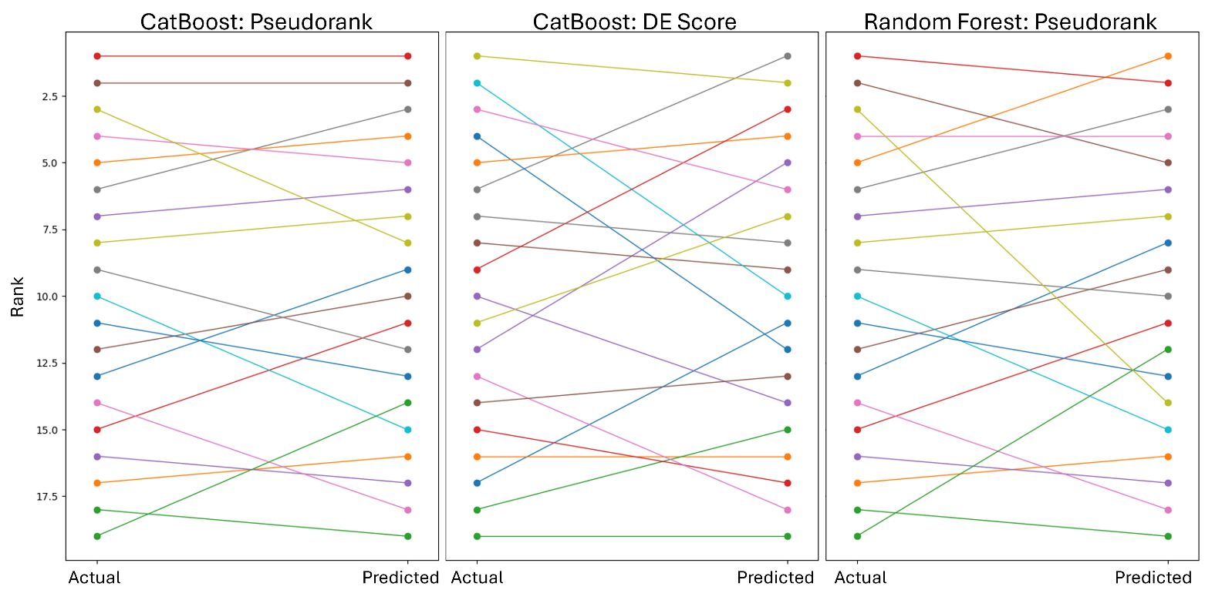
Figure 8: Comparisons of actual donor order based on Pseudorank (left, right) and DE Score (middle) to the predicted donor order from CatBoost (left, middle) and Random Forest (right) learners.
CatBoost and Random Forest regressors were further evaluated by the number of the top three donors correctly identified, the number of the top five donors identified, and by their mean rank error, which is the average difference between the actual and predicted rank (Table 4). These results indicate that the CatBoost learner trained to predict Pseudorank is the most successful at predicting donor order. As finding the top donors is likely to be the most useful function of this model in practice, optimization will continue with the CatBoost Regressor predicting Pseudorank using top individual genes as features.
Learner, Target | # of Top Three | # of Top Five | Mean Rank Error
CatBoost, DE Score | 1 | 2 | 3.47
CatBoost, Pseudorank | 2 | 4 | 2.32
Random Forest, DE Score | 0 | 2 | 3.58
Random Forest, Pseudorank | 1 | 4 | 3.05
Table 4: Summary of donor ranking by top learners.

Optimizing Feature Selection
Previous feature selection for the donor_rank dataset was done by selecting the genes with the greatest absolute linear correlation with Pseudorank. While sufficient for learner screening, tree based models are not restricted to using linear relationships as branch points, so this method may miss key genes. To address this, a new dataset was made by running the CatBoost learner on the full donor_adata object with 11,000 and then calculating feature importance. The 100 genes with the greatest feature importance were collected into a new dataset called donor_100 that will be used for model optimization.
The next step in feature selection is to determine the optimal number of features for making prediction without overfitting. To do this, the CatBoost learner was run on the donor_100 dataset sorted for feature importance with a progressively limited number of features. The lowest test set MAE was found to be between 5 and twenty features for this train/test split.
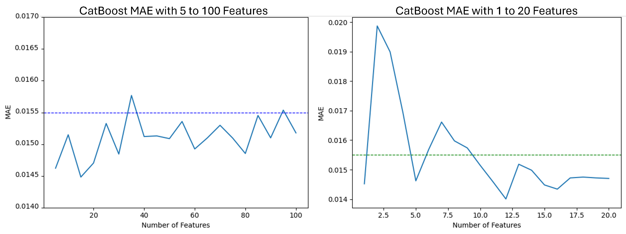
Figure 9: CatBoost Regressor trained with donor_100 sorted by feature importance with limited feature number.
Random selection of donors for the training and test sets was found to be a source of variability in this dataset. Once it was determined that the less than thirty genes was sufficient to train the model, the CatBoost learner was run on up to the thirty most important genes over 20 splits. For each split, the most important six, ten and twenty-four genes were collected. The results of this experiment are shown in Figure 10.
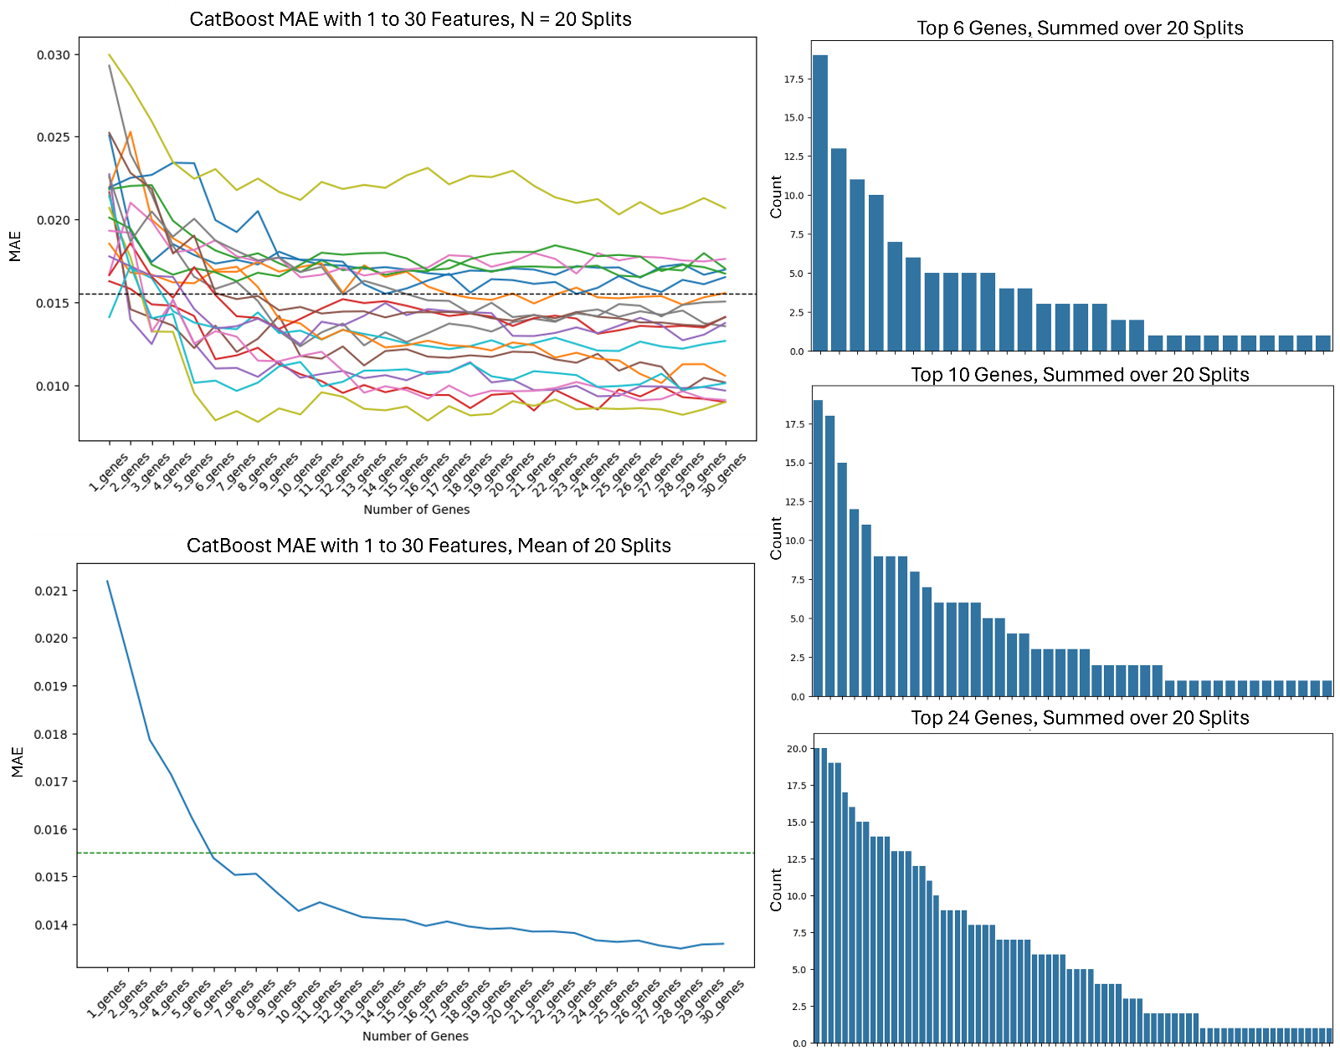
Figure 10: Feature Selection from donor_100 by the CatBoost Regressor. Top Left: MAE with top one to thirty genes over twenty splits shown separately. Green dashed line indicates the MAE from model screening of the CatBoost Regressor. Bottom Left: Mean MAE of the twenty splits with one to thirty features. Right: Counts showing the number of times individual genes were selected as the most important six (top), ten (middle) or twenty-four (bottom) features out of twenty splits. Please see associated Jupyter Notebooks for gene names.
The results of Figure 10 confirm four observations:
- The mean MAE plateaus around twenty-five genes and most individual splits plateau around twelve genes. This indicates that twenty to twenty-five genes are sufficient to train an accurate model.
- The list of 'top 6 genes' has 28 genes in it, ‘top 10 genes’ has 43 genes and ‘top 24 genes’ has 73 genes that were selected in at least once over twenty splits. This confirms there is variability in the genes selected for different splits and leads to the conclusion that there there is redundancy in the dataset such that different sets of genes can be used to make similar predictions.
- Some genes are more likely to be selected than others. SLC25A5, for example, was selected as being very important with almost every split.
- There are twenty-two genes that were selected in the ‘top 24 genes’ nine or more times out of twenty splits. Twenty-one of these genes are also in the ‘top 10 genes’ list and nineteen are in the ‘top 6 genes’ list. These genes could be a core subset that could make concise dataset that could be used for any split.

Final Model Optimization through Manual vs Automated Gene Selection
We now have a list of twenty-two specific genes that can be used as our final dataset to train the model. However, hardcoding these specific genes into the model limits the generalizability of the model to future datasets. We therefore wanted to compare models trained on this specific gene list to models trained on gene lists automatically chosen for the specific split. First, a ‘selector’ CatBoost learner was trained on twenty random splits of donor_22, which only contains the manually chosen twenty-two genes selected 9+ times in the ‘top 24 genes’ from Figure 10. For each split, the relative feature importances were calculated and sorted. A second ‘predictor’ model was then trained on one to twenty-two features from the sorted list to generate the MAE features selection curves for each split (Figure 11a). This process was then repeated with automatic feature selection, where for each split the ‘selector’ CatBoost model was trained on donor_100 and then the top twenty-two genes were selected for each split. The ‘predictor’ model was then trained on one to twenty-two features from this split-specific sorted list to generate the MAE features selection curves (Figure 11b). The mean MAE across the twenty splits for manual and automatic gene selection are show in Figure 11c and the feature importance for the twenty two genes in donor_22 is shown in Figure 11d. These results show that while manual gene selection has a lower MAE for most feature numbers, both manual and automatic models have very low mean MAE curves that are below the MAE found during model screening (Figure 11a-c, green line) and well within the functional error limits for this project.
Two different methods of automatic gene selection were tested. Recursive feature elimination (RFE) was run through the process described above (not shown) and found to be too variable between splits (Figure 11e). Shap values calculation and thresholding from the ‘selector’ model was then tested with Shap thresholds of 0.01, 0.005, 0.001, 0.0005 and 0.0001 (Figure 11e). A Shap threshold of 0.0005 was selected as it had the lowest MAE across twenty splits with up to 22 features. In addition, a Shap threshold of 0.0005 resulted in 20-22 genes selected for most splits (Figure 11f) whereas higher thresholds reduced models to five or fewer genes and lower thresholds allowed in more than 22 genes were then capped at 22, rendering the threshold ineffective. The feature selection curves shown in Figure 11b were made using Shap value gene selection with a threshold of 0.0005.
For our final model, we made one with manual gene selection trained on donor_22 which had a final MAE test of 0.09986 and an automatic gene selection model with a Shap threshold of 0.005 and a cap of twenty-two features with a final MAE test of 0.01017.
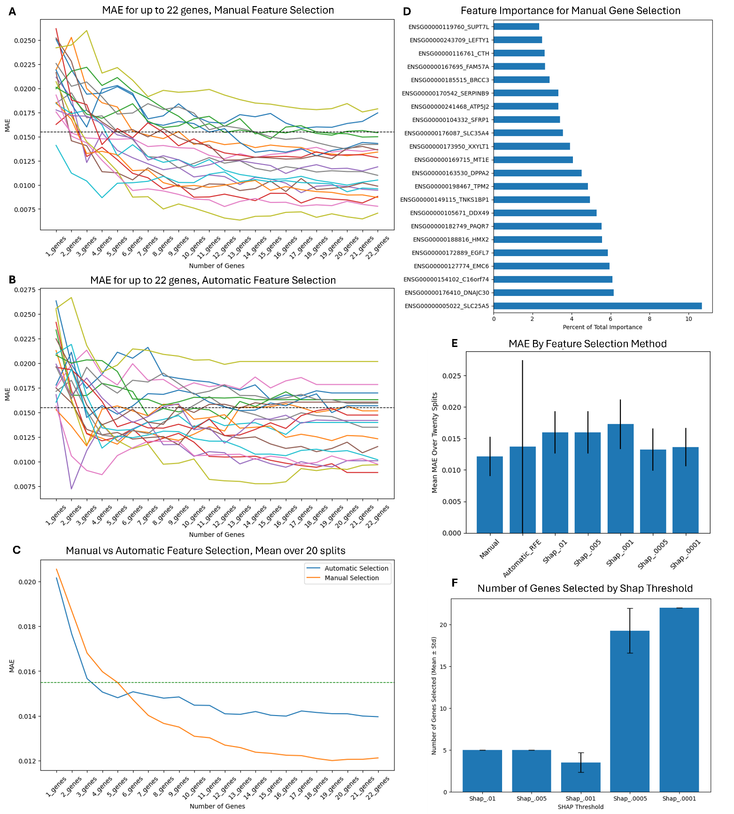
Figure 11: Manual vs Automatic Gene Selection. A) Feature selection curves over 20 splits using manual gene selection with a model trained on a dataset of 22 specific genes. B) Feature selection curves over 20 splits using automatic gene selection of up to 22 genes above a Shap threshold of 0.0005. C) Mean MAE for feature selection curves over twenty splits from panel A (orange) and panel B (blue). D) Feature importances from manual gene selection averaged across twenty splits. E) Mean MAE from twenty splits with up to 22 genes comparing methods of gene selection. F) Mean number of genes with passing Shap values between different Shap thresholds.

Future Work
When designing our final model, it is very impmortant to condsider how this model will be used. The main challenge with building a model based on gene expression for a single experiment is generalizability to other datesets and research scenarios. If the model is intended for a single research group to make predictions on new datasets generated using identicle experimental protocols and equipment, a model trained on the final twenty-two genes identified in this analysis would be the ideal result. However, if the goal is to make a model that can be used by other labs or be applied to any other situation, we must account for potential sources of variability between future datasets. We have already seen that random donor assignment during the test/train split was the largest source of variability in MAE and feature selection when building the donor_adata model. It is therefore likely that new datasets would require a different set of about twenty genes to make accurate predictions. Building a model with manual selection of these specific twenty-two genes would severaly limit generalizability to additional datasets. Alternatively, building a model that has automated selection of the best twenty-two genes for the specific data it was trained on allows dissemination of the model across labs who could repurpose the pipeline for their own uses. The model could be retrained to predict iPSC differentiation into alternative cell types or predict differences between clones in a functional assay during later stages of drug development wth minimal alterations. The benefit of this model lies in the pipeline and ease at which it can be repurposed to different needs.
Further improvements to this model require include testing this repurposing to similar datasets. For example, there is a similar dataset that compares iPSC donor differentiation into midbrain neurons (Jerber, et al.) that includes iPSC RNAseq that could be used for just such a test. The following pipeline could be applied to that dataset:
- Determine the target variable.
  - This can be done using the pseudotime function or made new from any relevant data.
- Convert single-cell data to bulk counts if necessary.
- Use the CatBoost Regressor run on the to pick the top 20-25 genes.
  - If further optimizations are desired, pick the top 100 genes first, then run MAE curves over 1-30 features over multiple splits to find the ideal feature number.
- Train the model with the top genes.
- Test predictions with MAE and donor ranking as metrics.
Once this approach has been validated, it can be applied to several situations common in cell therapy with further model development on more complex datasets. It is our hope that this work serves as proof-of-concept for what might be possible and motivates generation of the necessary data. Some examples are as follows:
- Donor selection for any iPSC differentiation. Cell types relevant to cell therapies include neurons for treating neurodegenerative diseases such as Parkinson’s, immune cells for treating cancers or autoimmune diseases, or beta islet cells for treating diabetes.
- iPSC clone selection for drug development. In this scenario, the model would most likely be repurposed to predict a functional readout such as killing efficiency in the case of immune cells or insulin production in the case of beta islet cells.
- Correlating iPSC clone data with in vivo experimental results from animal studies. These studies are extremely expensive, and companies often can only apply them to their top few clones. The model could be used to better understand the features which impact iPSC clone performance in these studies, or maybe even further developed to perform the clone selection by predicting in vivo results.

References
Chu LF, Leng N, Zhang J, Hou Z, Mamott D, Vereide DT, Choi J, Kendziorski C, Stewart R, Thomson JA. Single-cell RNA-seq reveals novel regulators of human embryonic stem cell differentiation to definitive endoderm. Genome Biol. 2016 Aug 17;17(1):173. doi: 10.1186/s13059-016-1033-x. PMID: 27534536; PMCID: PMC4989499.
Cuomo, A.S.E., Seaton, D.D., McCarthy, D.J. et al. Single-cell RNA-sequencing of differentiating iPS cells reveals dynamic genetic effects on gene expression. Nature Communications, 11, 810 (2020). https://doi.org/10.1038/s41467-020-14457-z
Jerber J, Seaton DD, Cuomo ASE, Kumasaka N, Haldane J, Steer J, Patel M, Pearce D, Andersson M, Bonder MJ, Mountjoy E, Ghoussaini M, Lancaster MA; HipSci Consortium; Marioni JC, Merkle FT, Gaffney DJ, Stegle O. Population-scale single-cell RNA-seq profiling across dopaminergic neuron differentiation. Nat Genet. 2021 Mar;53(3):304-312. doi: 10.1038/s41588-021-00801-6. Epub 2021 Mar 4. PMID: 33664506; PMCID: PMC7610897.
Liberzon A, Birger C, Thorvaldsdóttir H, Ghandi M, Mesirov JP, Tamayo P. The Molecular Signatures Database (MSigDB) hallmark gene set collection. Cell Syst. 2015 Dec 23;1(6):417-425. doi: 10.1016/j.cels.2015.12.004. PMID: 26771021; PMCID: PMC4707969.

